Understanding Workplace Operations
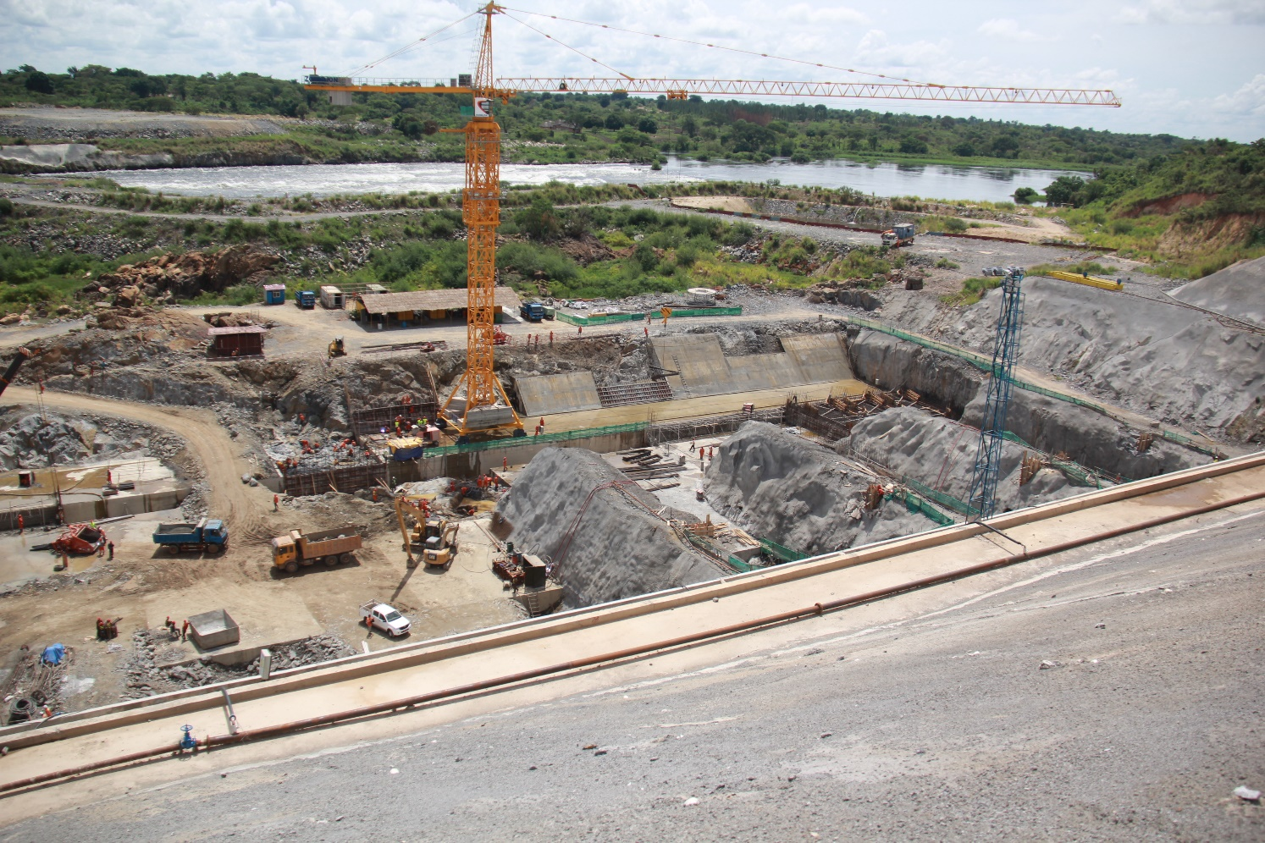
The workplace environment is best facilitated by the learning process derived out of the intelligence of the people involved in workplace and is most facilitated by their emotional intelligence. Understanding the emotional intelligence will make the workplace better. (Everyone has workplace to support livelihood)
“There’s been a quantum leap technologically in our age, but unless there’s another quantum leap in human relations, unless we learn to live in a new way towards one another, there will be a catastrophe.” Albert Einstein

The basics of the subject are discussed, cover the following points in this starter blog. The application of human Intelligence shall be discussed in the further blogs.

Workplace
Workplace Environment?
Workplace Processes
Workplace Improvement
Workplace Development
Google Working Output

The Workplace Defined
The world, and any platform on it, is a place to work for all living beings. Everyone must work to survive. And this platform is called workplace.

This workplace is confined with a boundary. This boundary provides an environment inside where human and non-human work.

The environment outside this boundary is full of probabilities and complexities. The outcome of exploration of this environment helps in managing the workplace. The exploration is important to understand the pressure of complexities and how to handle them. The favorable conditions in outside environment shall help in expansion of the workplace.

Health, Safety, and Security are other factor which support the workplace environment and every human is aware of it.
One of the factors associated with the workplace environment is the quality of people working in it. It depends on the Intelligent Quotient of the personnel and their Emotional intelligence.

Why Workplace Environment?
A good workplace environment provides a feeling of wellness and positivity for actions there.
The following quote supports the requirement.

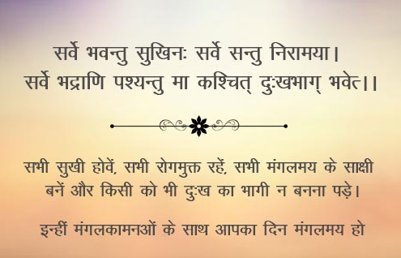
Translation…………..
“M ay All become Happy,
May All be Healthy (Free from Illness)
May All See What Auspicious is ,
May no one Suffer in any way .”

The Workplace Processes
The workplace planning, design, construction, and facilities provisions have improved since long and other modern tools and techniques are being utilized to improve the workplace environment further. The actions provide the results to achieve satisfaction level.
In this blog only, the important aspects of operations of the workplace is being considered which ultimately depends on the work force.
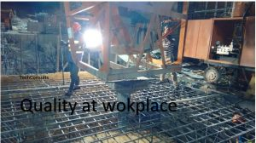
It is the quality of the action that provide satisfactory results. Therefore, workplace environment must be supported from quality actions. It is well known that at different workplaces specialized individuals with same type of qualifications and training are employed. But all of them do not reach at the top level, being at the same level initially. All MBA cannot be chief business administrators, or all engineers cannot be chief engineers, directors, and CEOs. This depends on workplace positive environment and in the quality of people involved.
Work environment depends upon the employee’s involvement with the work, organization culture, and the relationship among the workforce. It may accordingly be good or bad.
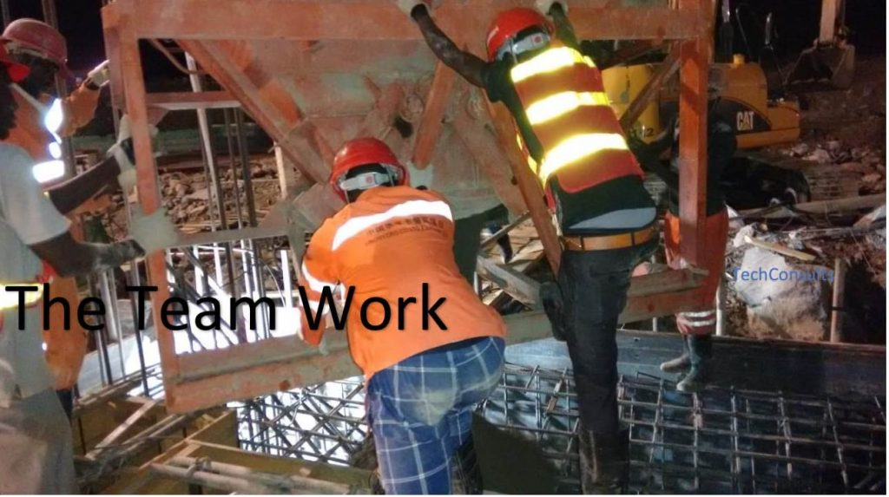
The work environment has great importance for workplace but ultimately it is the workforce that manages the environment. Everybody is member of the workforce by default, and it is who must maintain the work environment out of workplace, be it worker, developer or operator.

Improve Your Workplace
Find the way to work. it is always there.
“The better able team members are to engage, speak, listen, hear, interpret, and respond constructively, the more likely their teams are to leverage conflict rather than be levelled by it.” Rundu and Flanagan
Do not doubt anybody unless situation is fully explored.
“10% of conflicts are due to difference in opinion. 90% are due to wrong tone of voice.”
Be it a matter of loss or gains -act fast.
Appreciate
Do not speak ill of others.
“I’ve always believed that a lot of the troubles in the world would disappear if we were talking to each other instead of about each other.” Ronald Reagan
Stay plosive, work hard, and make it happen.
How to bring positive environment at the workplace?
Bring people together.
Workplace Development
Develop Emotional Intelligence (EI) of the people of workplace. Mostly the work force is appointed based on the qualification and Intelligence Quotient (IQ) tests and is left to the environment for actions. This is not fair. Along with IQ if Emotional Intelligence (EI) is developed the work environment will be better.
Test yourself with the impossible and you shall know your capabilities.
“When dealing with people, remember you are not dealing with creatures of logic, but creatures of emotion.” Dale Carnegie

Google Working Output
The ‘Business Insider India’ elaborates 5 reasons why Google is best place in the world to work.


Googlers are extremely satisfied to fairly satisfied.
Googlers think that their work makes the world a better place. Google say that their compensation is the best.
More than 25% of Googlers telecommute at least some time.
Some employees sat their job is of low stress.
In the google work environment the people are emotionally intelligent.

Workplace environment plays an important role in managing the output level and the major part in it is played by the human resources. The human resources are appointed mostly based on cognitive status (IQ).The output shall be steady if Emotional intelligence is also developed in the entire team.

NEXT Emotional Intelligence use at Workplace

