Importance of Emotional Intelligence at Workplace (1)/ (2)

General
What does workplace mean?
Workplace - a place where work is done. It applies for all the type of work done from morning to next morning, 24 x 7. The human being is blessed by god and is different than animals. He can think and act, rethink and perform.
The actions associated with human being not only help him to sustain life but do more for their generations to come.
Success is the ultimate gain of all actions. Failures in achieving success help us to learn more, which further help us to gain the success. Following attributes are important to gain success:

Attributes | Definitions
Desire | The right desire for doing the right things at right time for a right purpose
Direction | Can be got from education , environment and experience and available wisdom (other’s experiences)
Dedication | The quality of being dedicated or committed to a task or purpose.
Discipline | To act in a disciplined way for all activities related to workplace – maintaining planning, scheduling, costing quality risk avoidance measures etcetera

Attitudes play an important part in workplace environment management methods, and these methods require not only Intelligent Quotient (IQ) but a more important Emotional Intelligence (EI). It is the EI that makes the result better and increases individual’s competence level.

HR Appointment and Development Aspects

The technical knowledge is an important requirement for selecting human resources (HR) for various disciplines and department. Usually, HR selection is done based on technical knowledge initially and objectively tested For Intelligent Quotient (IQ)
But ultimately it is the human behavior that is required for the successful handling of work operations and the desired output.
The behavior aspect is genetically inbuilt in human nature and can be developed for better management practices.
It can be developed through the knowledge of Emotional Intelligence (EI), also known as Emotional quotient (EQ)
It is necessity to have an applicability understanding of EI/EQ knowledge for better management at the work place.
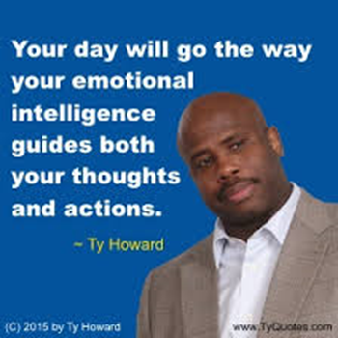

HR and Emotion Intelligence

EI/EQ helps in the development of individuals, in the development of team and in the development of leadership which ultimately enhances the organizational development.
Human Resource with less EI/EQ contents are
aggressiveness,
demanding,
ego problems,
bossy,
confrontational,
easily disturbed,
poor listener,
impulsive,
passive,
resistance to change,
non-responsiveness,
stubborn,
hard to please,
and believe in perfectionism etcetera.
Human Resources with high EI/EQ contents are
ambitious,
driving,
strong,
decisive,
warm,
enthusiastic,
sociable,
persuasive,
patient,
stable,
practicable,
predictable,
consistent and good listener.
Also, the HR with enhanced EQ/EI get better grades, are cooperative and become better managers.
About Emotional intelligence

Everybody wants to achieve success in his life in his field of activities-it may be at home, in office, in the society etcetera.
Environment, Experience and Education (in complete meaning) provide pushbacks to the achievement of the Success in various fields. The three factors along with IQ (which rarely improves) boost your success and it is true.
But further success can be achieved by EQ / EI (Emotional Intelligence).
It works beyond education and IQ. Emotional intelligence refers to -How your emotions influence your life at work and home- Unlike IQ, the emotional Intelligence can be improved.

EI/EQ revolves on the following points.
Know your Emotions- SELF Awareness 

Manage Your Emotions and motivate yourself-SELF Management
Recognize and understand other People’s emotions-SOCIAL Awareness
Manage other’s emotions- Relationship Management
Try understanding Emotion Intelligence subject for successful and happy life. Emotional intelligence is the ability to sense, understand, and effectively apply the power and acumen of emotions as a source of human energy, information, connection, and influence. -- Robert K. Cooper. Ph.D.

In IQ the cognitive abilities are assessed through vocabulary reading, comprehension and mathematical and reasoning skills and assessment is based on the scores assigned to assess intelligence abilities and this practice exists even in higher educational competitions and is recommended in various private and government organization and in the international transfers of human resources. (It is based more on objectivity)

What Daniel Goleman, the developer of emotional intelligent concept says.

In year 1985 emotional intelligence (EI, and known as Emotional Quotient EQ) was advocated, but ultimately Daniel Goleman in 1995 made efforts for its better understanding and use.
EI/ EQ is individuals ability to identify, understand, evaluate control, and express emotions of self and others and groups. (It is based more on subjectivity) Together IQ and EQ provide success in practically all the fields.

The summery

If you want maximal productivity and if you want work that gets the best results, you want the people doing that work to be in the optimal brain state for the work. You are a person who can evict them from the zone of optimal performance by slothfully handling your own interactions with them. So, it's up to you to take responsibility for your impact on their ability to work at their best. -- Daniel Goleman | 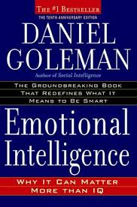

Additional Bog Lnks

A little more about the EI/EQ - in the next EI/EQ blog (2)/ (2)

General-Blog posts from Tec Consults shall be based on the topics given in the ‘JOIN US’ page, but not limited to available list of topics on the http://techconsults.in. Viewers are now free to join TecConsults and can contact sksaxena@techconsults.in for their suggestions for managing the main and sub topics.

General
HR Appointment and Development Aspects
HR and Emotion Intelligence
About Emotional Intelligence
What Daniel Goleman, on EI
The summery
Additional Bog Links

